**Batteryless and Wireless Implant**

**and Data Acquisition System**

**User Documentation**

**Faculty Mentor:**

Dr. Jonathan Valvano

**Team Members:**

Corey Cormier

Thomas Ermis

Albert Marzullo

Michael Park

Makeila Sorensen

Anish Vaghasia

The University of Texas at Austin

Cockrell School of Engineering

Electrical and Computer Engineering Department

Fall 2016

1. **Overview**
   1. This document describes the procedure for recreating the Batteryless and Wireless Implant and Data Acquisition System
2. **Important Hardware**
   1. MSP430 USB-Debug-Interface

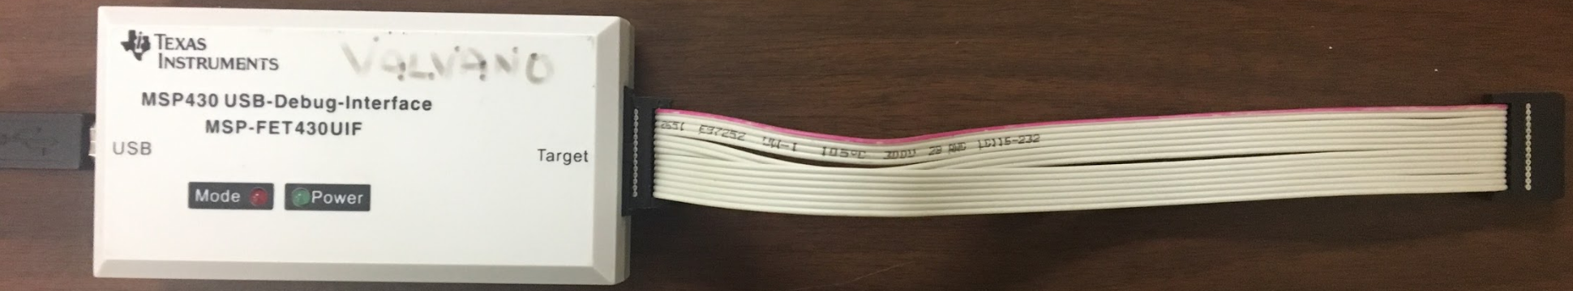

* 1. RF430FRL152H EVM (<http://www.ti.com/tool/RF430FRL152HEVM>)

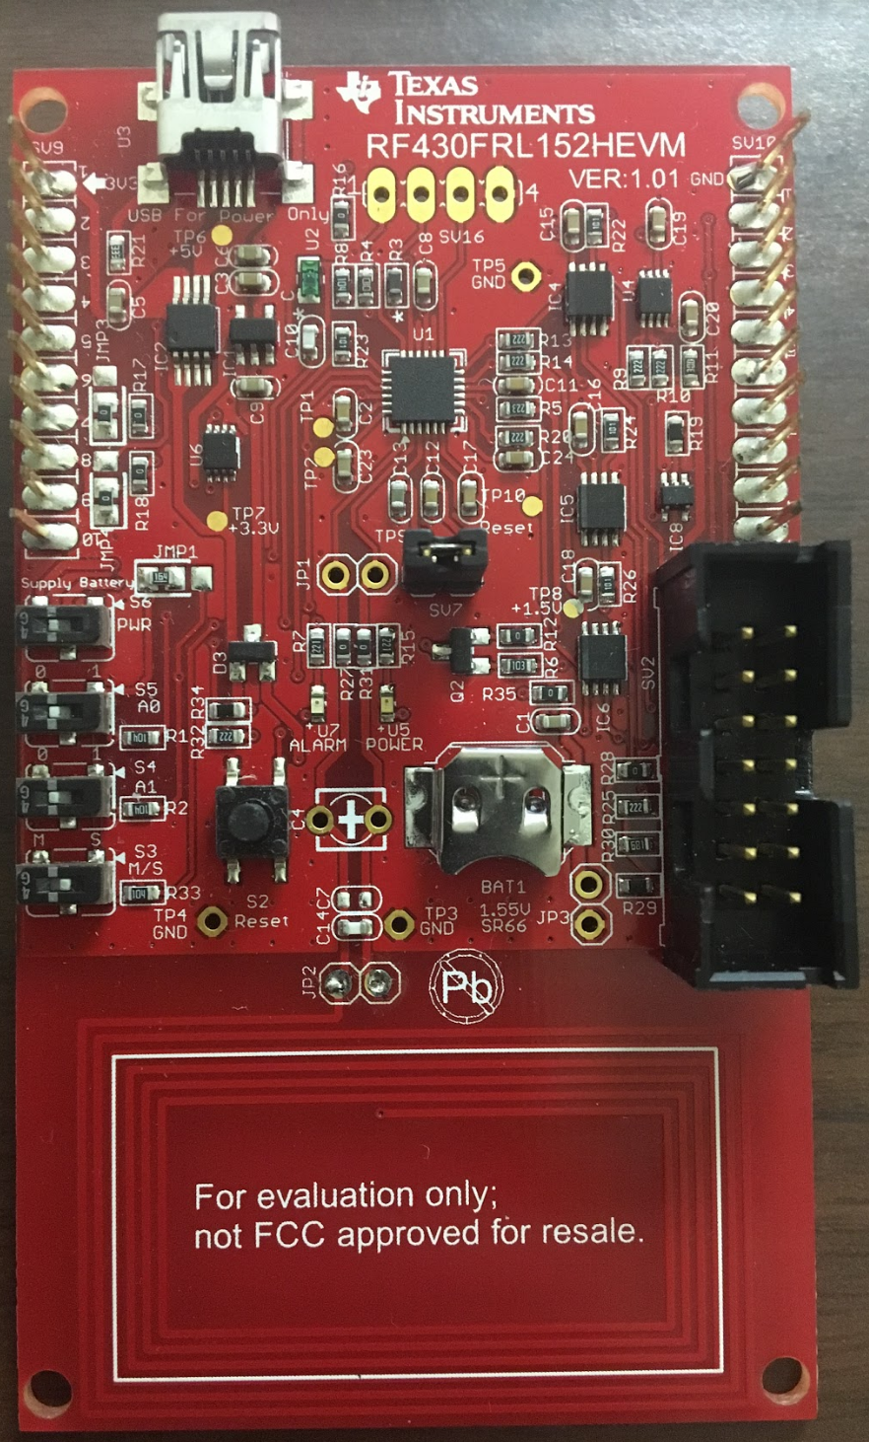

* 1. RF430FRL152H VQFN (<http://www.ti.com/product/RF430FRL152H>)

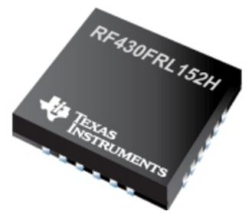

* 1. RF430 Socket Board (Not commercially available)

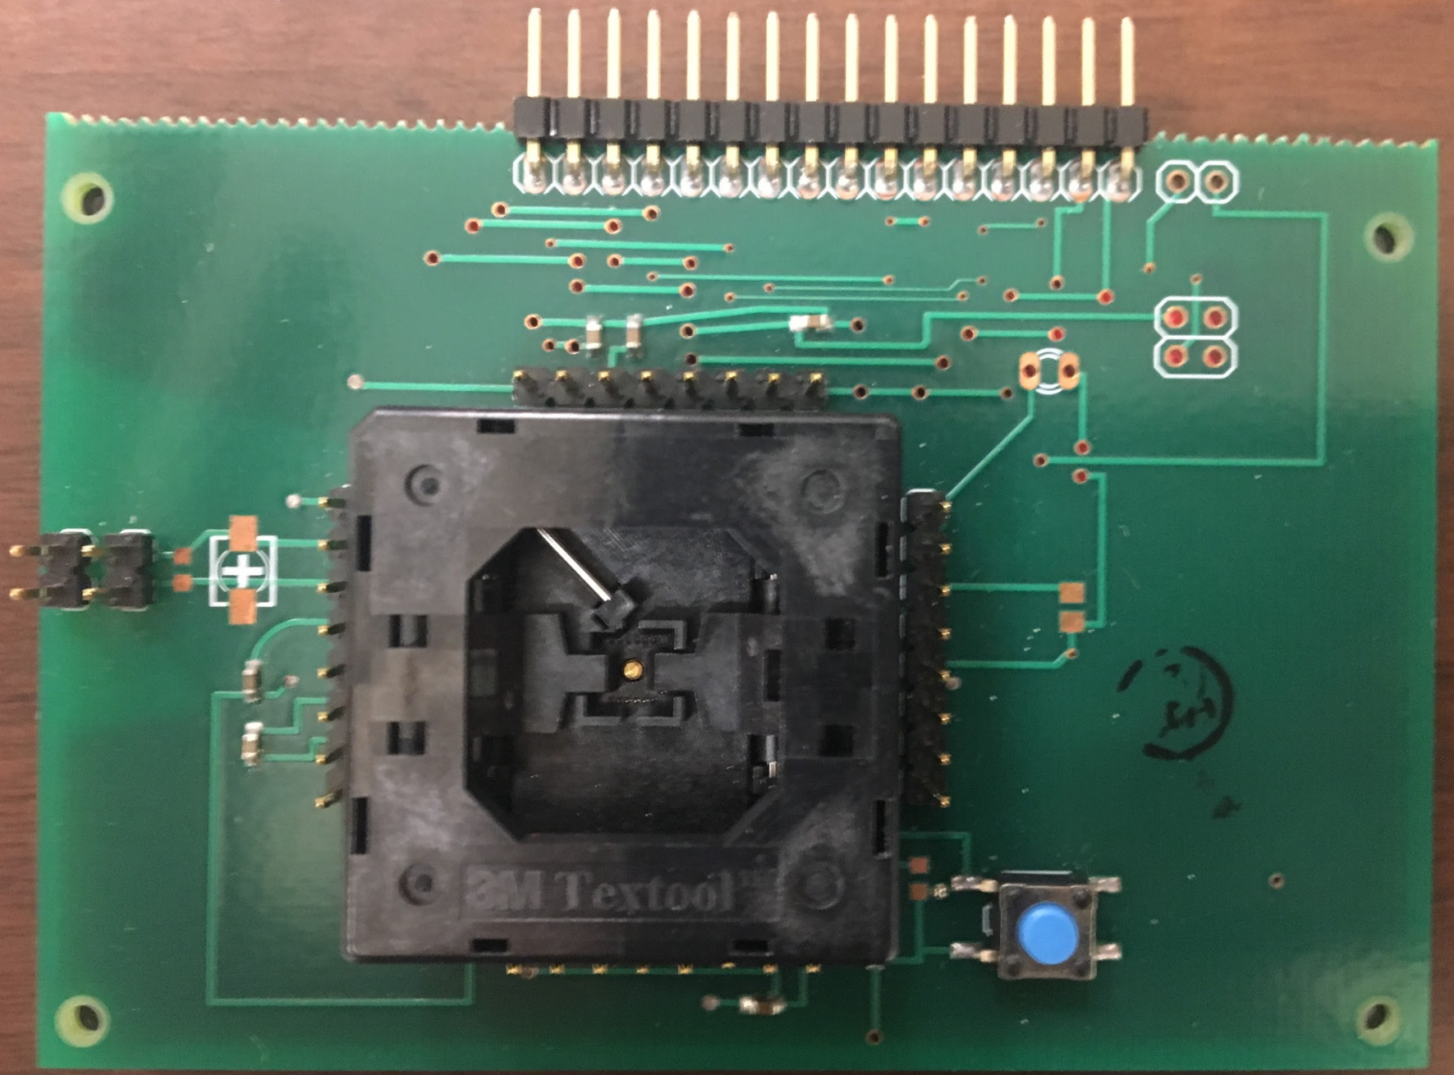

* 1. RF430 JTAG Level Shifter Board (Not commercially available)

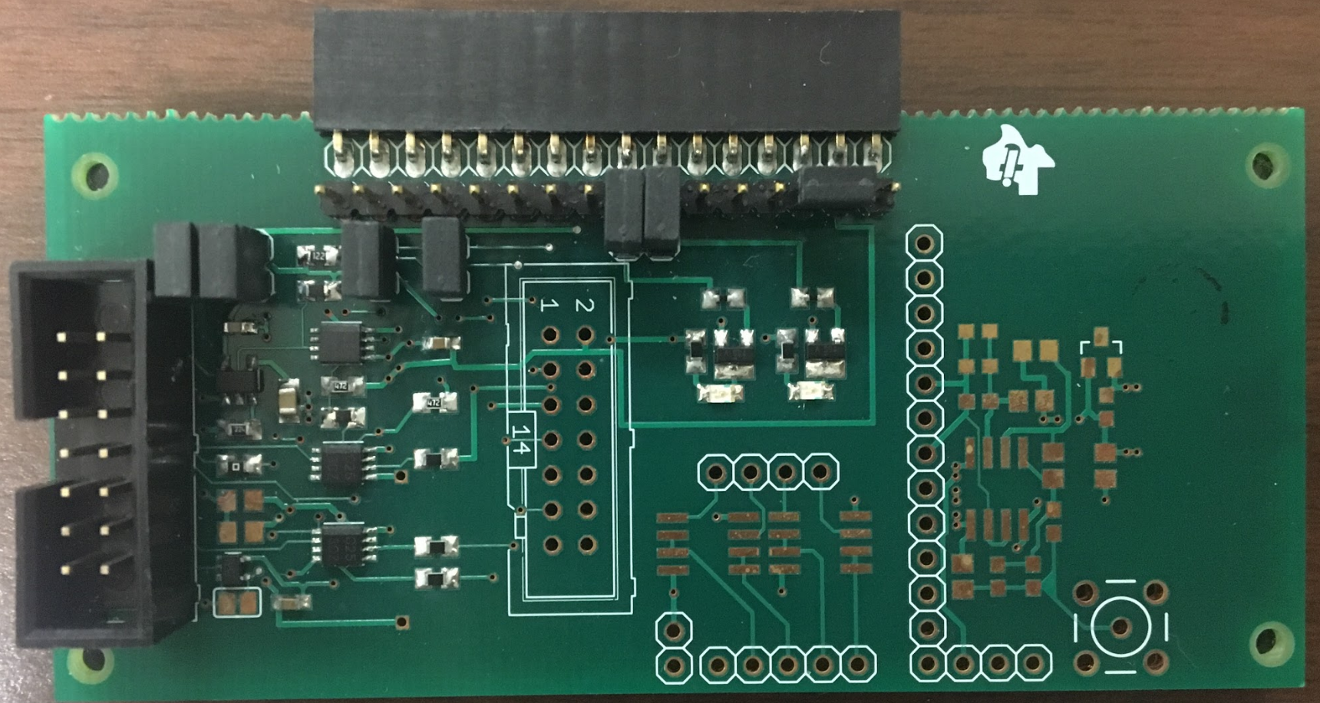

* 1. TRF7970A EVM (<http://www.ti.com/product/TRF7970A>)

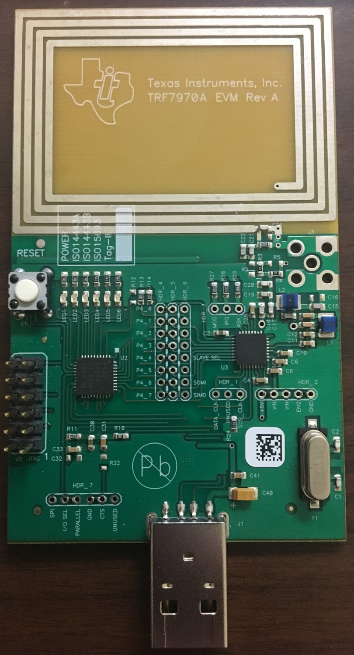

* 1. Raspberry Pi 3 Starter Kit (<https://www.amazon.com/CanaKit-Raspberry-Complete-Starter-Kit/dp/B01C6Q2GSY>)

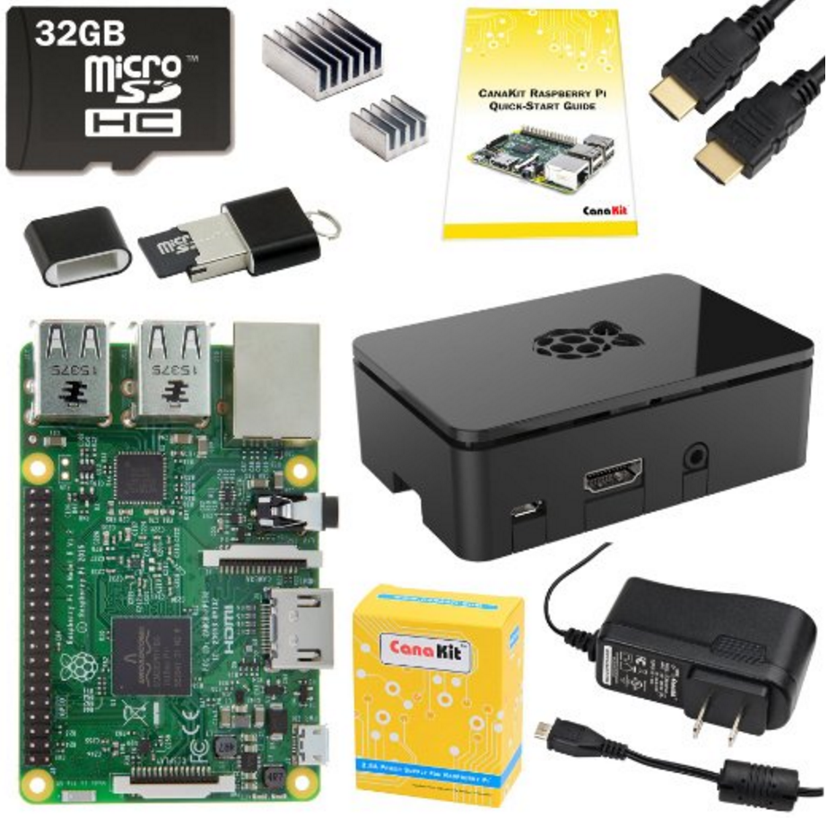

1. **Important Software**
   1. Implant Source Code
   2. Code Composer Studio
   3. TRF7970A GUI
2. **Implant Source Code**
   1. Download & Extract
      1. Navigate to “1-implant” > “2-software”
      2. Within “2-software”, there are two projects, “implant_barebone” and “implant_full”
      3. Download the two projects, “implant_barebone” and “implant_full”
      4. The “implant_barebone” project has basic support for custom commands
         1. Upon sending a custom command, that custom command is echoed back
      5. The “implant_full” project has full support for internal temperature and triple-axis acceleration commands
         1. Upon sending the internal temperature command, an internal temperature measurement is returned
         2. Upon sending an x, y, or z-axis acceleration command, the corresponding acceleration measurement is returned
3. **Code Composer Studio**
   1. Download & Installation
      1. Go to <http://www.ti.com/tool/ccstudio>
      2. Download CCS
         1. OS: Windows 7, Windows 10
         2. CCS: Version 6.2.0.00050
      3. Install CCS
         1. Product Families: All
         2. Debug Probes: Default
   2. Import & Build
      1. Open CCS
      2. Navigate to “File” > “Import”
      3. Expand “Code Composer Studio”
      4. Select “CCS Projects” and click “Next”
      5. Browse to the “implant_barebone” or “implant_full” project and click “Finish”
      6. Build the project by clicking on the hammer icon
   3. Debug & Run
      1. Set up the RF430FRL152H to be programmed
         1. Refer to “Programming the RF430FRL152H”
      2. Debug the project by clicking on the bug icon
      3. Run the project by clicking the play button
      4. The RF430FRL152H should now be programmed
4. **TRF7970A Windows GUI**
   1. Download & Installation
      1. Go to <http://www.ti.com/product/TRF7970A>
      2. Navigate to “Tools & software” > “Software”
      3. Download “TRF7970AEVM GUI WIN 7”
      4. Extract the zip file, “sloc301.zip”
      5. Save the executable, “RFIDread Win 7.exe”
   2. Operation
      1. Insert the TRF7970A into your laptop
      2. Run the executable, “RFIDread Win 7.exe”
      3. Navigate to the “15693” tab
         1. Check the console for the “COM Port found!” message
         2. If not there, close out of the GUI, unplug the TRF7970A, and try again
      4. In the “Tag Flags” section, select “High Data Rate” and click “Set Protocol”
         1. Check the console for a set of commands and responses
         2. If you receive “Failed to open port COM1”, close out of the GUI, unplug the TRF7970A, and try again
      5. Navigate to the “Test” tab
      6. Place the RF430FRL152H within range of the TRF7970A
      7. In the“String to send textbox”, enter in the command and click “Send”
         1. Refer to “Communicating with the RF430FRL152H”
      8. The console should display the command sent, followed by the response
         1. Refer to “Communicating with the RF430FRL152H”
5. **Soldering the Implant PCB**
   1. Stage 1: RF430FRL152H VQFN + Passives
      1. Clean the PCB with isopropyl alcohol
      2. Solder the RF430FRL152H VQFN onto the PCB
         1. Apply flux to the PCB footprint of the RF430FRL152H VQFN
         2. Using a soldering iron, apply an even layer of solder onto each of the pins and onto the ground pad
         3. Using a heat gun, determine at which temperature the solder on the pins and the ground pad reflows
            1. The solder should reflow at approximately 280 C
         4. Place the RF430FRL152H VQFN on its PCB footprint, double checking the orientation and alignment
         5. With one hand, hold the RF430FRL152H VQFN in place
         6. With the other hand, hover the heat gun over the RF430FRL152H VQFN until the solder reflows
         7. Once the solder reflows, continue to hold the RF430FRL152H VQFN in place but remove the heat gun
         8. Once the solder cools, you can let go of the RF430FRL152H VQFN
         9. Apply flux to the sides of the RF430FRL152H VQFN
         10. Using a soldering iron, touch up the solder on the pins
         11. Apply flux to the via underneath the RF430FRL152H VQFN
         12. Using a soldering iron, touch up the solder on the ground pad through the via
         13. Clean around the RF430FRL152H VQFN with isopropyl alcohol
         14. Double check your soldering underneath the microscope
      3. Solder capacitors C1 through C9 onto the PCB
         1. The RF430FRL152H requires capacitors C1 through C9 in order to be programmed
      4. Clean the board with isopropyl alcohol
   2. Stage 2: JTAG Header + Wires
      1. Solder one 4x1 header onto the PCB for the power and ground test points
      2. Solder a second 4x1 header onto the PCB for JTAG
      3. Attach female to male wires to the headers
      4. Test programming the PCB Implant
         1. Refer to “Programming the RF430FRL152H”
      5. Test communicating with the PCB Implant
         1. Refer to “Communicating with the RF430FRL152H”
   3. Stage 3: MMA8452Q Breakout Board
      1. Solder one 6x1 header onto the PCB for the MMA8452Q breakout board
      2. Solder the MMA8452Q breakout board to the header
      3. Test programming the PCB Implant
         1. Refer to “Programming the RF430FRL152H”
      4. Test communicating with the PCB Implant
         1. Refer to “Communicating with the RF430FRL152H”
   4. Stage 4: Tuning Capacitor
      1. Solder the tuning capacitor onto the PCB in order to tune the resonant frequency of the coil
      2. Solder a wire onto each side of the tuning capacitor
      3. Test programming the PCB Implant
         1. Refer to “Programming the RF430FRL152H”
      4. Test communicating with the PCB Implant

Refer to “Communicating with the RF430FRL152H”

1. **Programming the RF430FRL152H**
   1. Open the CCS Project
      1. For initial programming tests, use the “implant_barebone” project
   2. Connecting the RF430FRL152H EVM
      1. Connect the RF430FRL152H EVM to your laptop for power
      2. Connect the MSP430 USB-Debug-Interface to your laptop and to the RF430FRL152H EVM

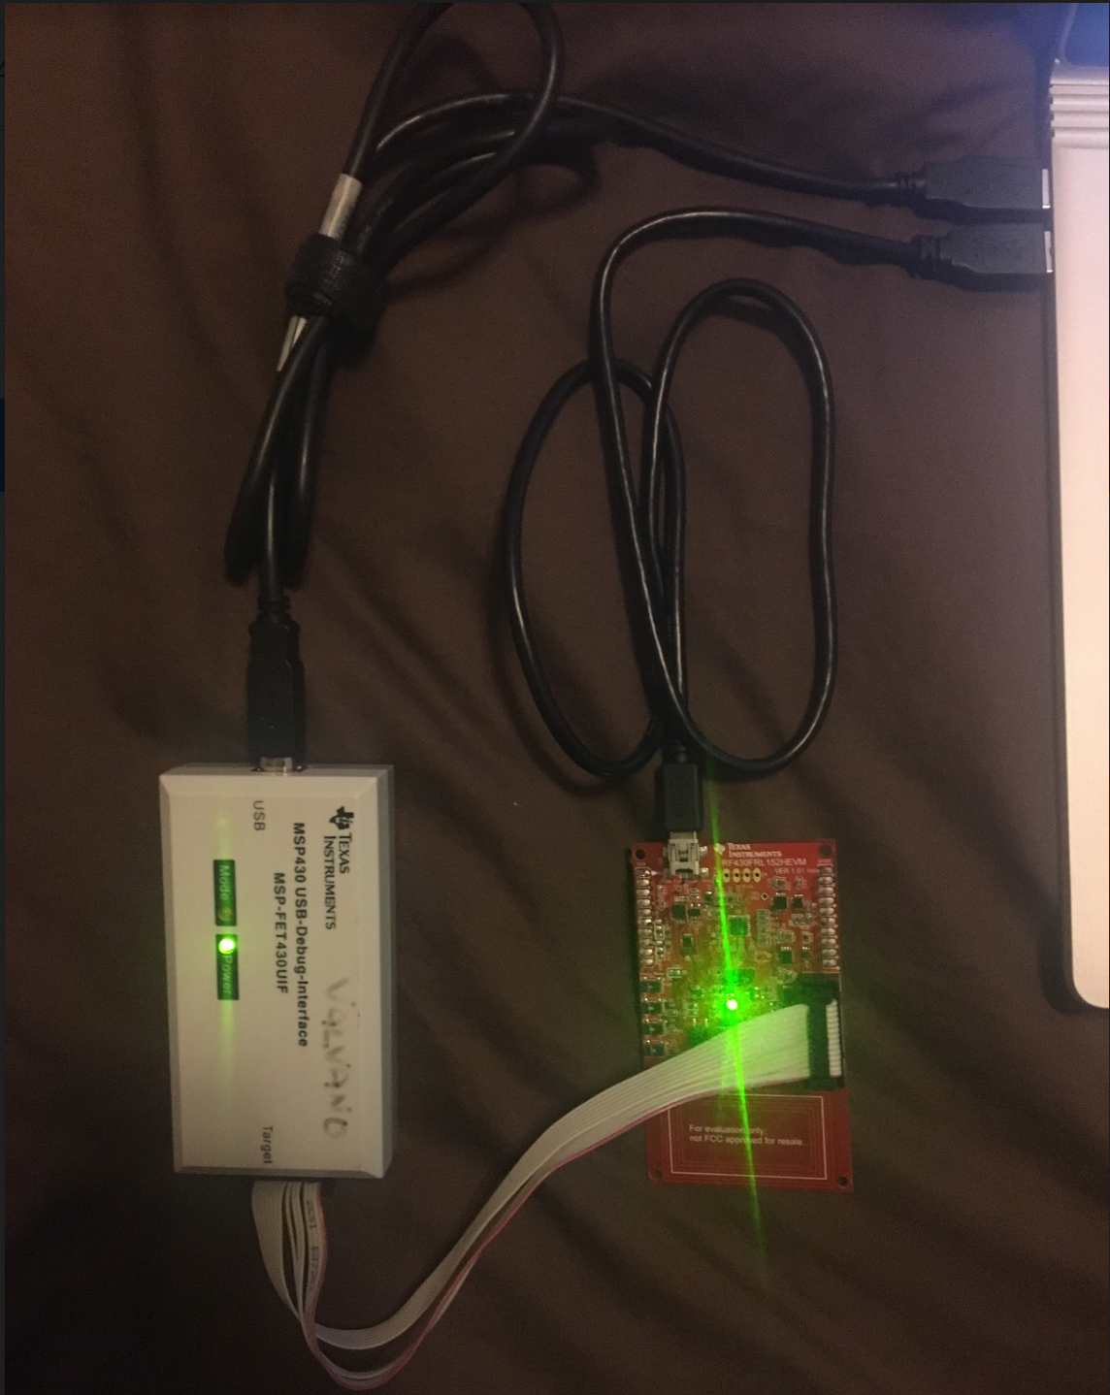

* 1. Connecting the RF430FRL152H VQFN
     1. Place the RF430FRL152H VQFN into the socket on the RF430 Socket Board
     2. Connect the RF430 Socket Board to the RF430 JTAG Level Shifter Board
     3. Connect the MSP430 USB-Debug-Interface to your laptop and to the RF430 JTAG Level Shifter Board

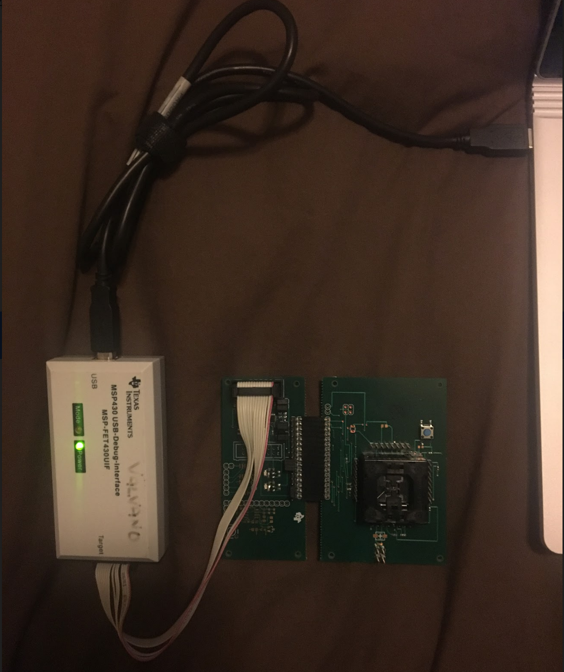

* 1. Connecting the Implant PCB
     1. Connect the Implant PCB to the RF430 JTAG Level Shifter Board
        1. Double check your connections

|  |  |  |  |  |  |  |  |  |  |
| --- | --- | --- | --- | --- | --- | --- | --- | --- | --- |
| RF430 JTAG Level Shifter Pinout  (Facing Pins, Left to Right) | | | 1 | 2 | 11 | 12 | 13 | 14 | 15 |
| Implant PCB  Test Point Connections | | | GND | VDDSW | TCK | TDI | TDO | TMS | RESET |

* + 1. Connect the MSP430 USB-Debug-Interface to your laptop and to the RF430 JTAG Level Shifter Board

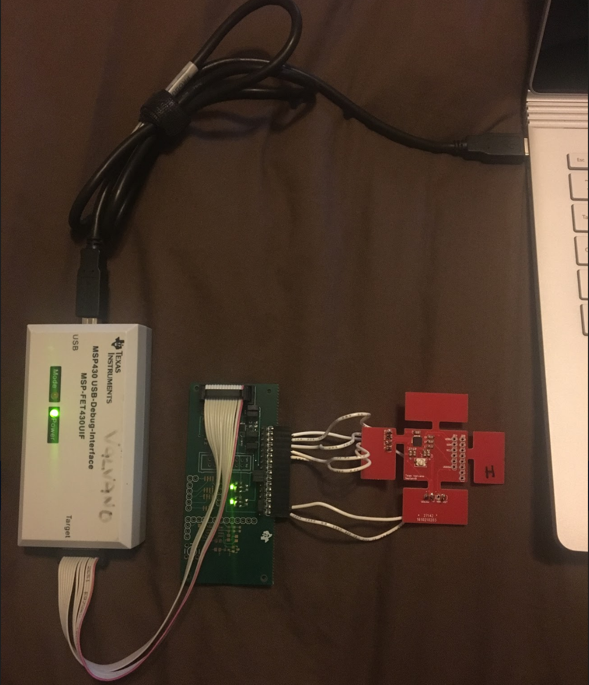

* 1. Debug the project by clicking on the bug icon
     1. If you receive “Error connecting to target: Unknown device”, double check your connections
     2. If you still receive “Error connecting to target: Unknown device”, the RF430FRl152H is most likely not soldered correctly
  2. Run the project by clicking on the play button
  3. The device should now be programmed

1. **Communicating with the RF430FRL152H**
   1. Run the TRF7970A Windows GUI
   2. In the“String to send textbox”, enter in the command and click “Send”
      1. The format of the command is “1802AA07XX”, where “XX” represents a custom command
      2. For the “implant_barebone” project, the value of “XX” can be any two-digit hex value
      3. For the “implant_full” project, the value of “XX” depends on what type of data you want to measure

|  |  |  |
| --- | --- | --- |
| **Data Type** | **Command Type** | **Command String** |
| Temperature | Measurement | “1802AA07FF” |
| Acceleration | Configuration | 1. “1802AA0700” 2. “1802AA0701” 3. “1802AA0702” 4. “1802AA0703” 5. “1802AA0704” |
| X-axis Measurement | “1802AA0705” |
| Y-axis Measurement | “1802AA0706” |
| Z-axis Measurement | “1802AA0707” |

* 1. The console should display the command string, followed by the response string
     1. The format of the response should be “Request Mode.”, a line break, and “[XXXX]”, where “XXXX” represents 2 byte word in little endian
        1. For example, if you receive “[ABCD]”, the correct order of the response is “CDAB”
     2. If you receive “Failed to open port COM1”, close out of the GUI, unplug the TRF7970A, and try again
     3. If you receive “[]”, the RF430FRL152H is most likely out of range
     4. If you receive “[z]”, the RF430FRL152H is most likely just barely out of range
     5. For the “implant_barebone” project, the value of “XXXX” should be the custom command echoed back
     6. For the “implant_full” project, the value of “XXXX” depends on what type of of command was sent

|  |  |  |
| --- | --- | --- |
| **Data Type** | **Command Type** | **Response String** |
| Temperature | Measurement | “[ABCD]” |
| Acceleration | Configuration | 1. “” 2. “” 3. “” 4. “” 5. “” |
| Acceleration | Measurement | “[ABCD]” |

|  |  |  |
| --- | --- | --- |
| **Measurement Type** | **Corrected Data** | |
| Temperature | TH0 = Manually measured temperature (C)  TI0 = Integer value returned from implant at TH0  TI = Integer value returned from implant  T (C) = TH0 + ((TI - TI0)*(1/37.5)) | |
| Acceleration | AI = Integer value returned from implant  if( AI > 2047) AI = AI - 2048;  A (m/s^2) = AI * 2 * 9.8 / 2048; | |

1. **Tuning the Implant**
   1. The Network Analyzer

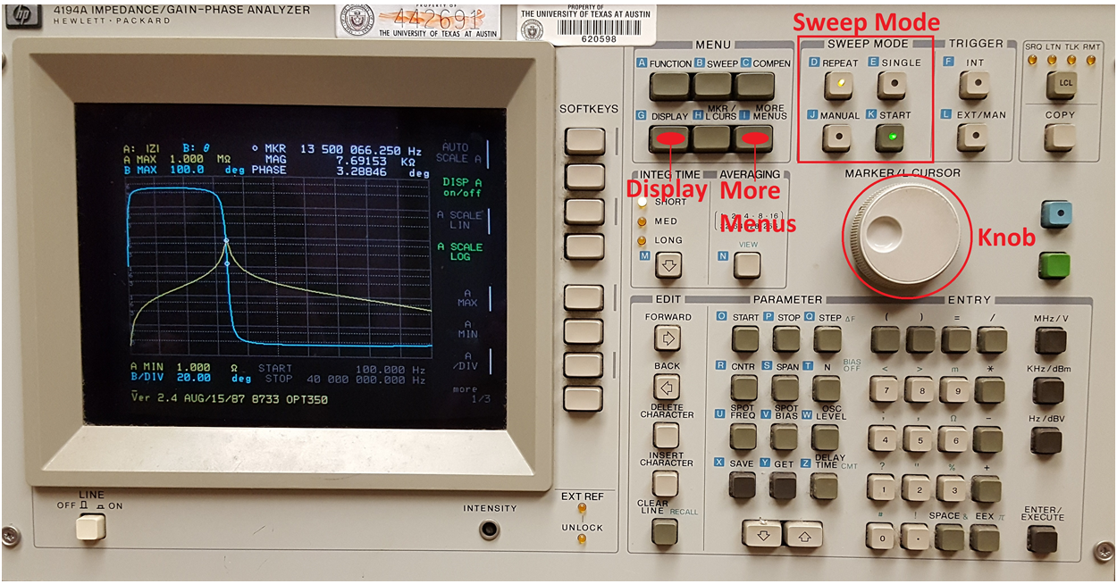

* + 1. Go to Dr. John Pearce’s lab at the University of Texas at Austin Pickle Research Campus
    2. Turn on the Network Analyzer
    3. Using the wires soldered onto each side of the tuning capacitor, connect the Implant PCB to the Network Analyzer

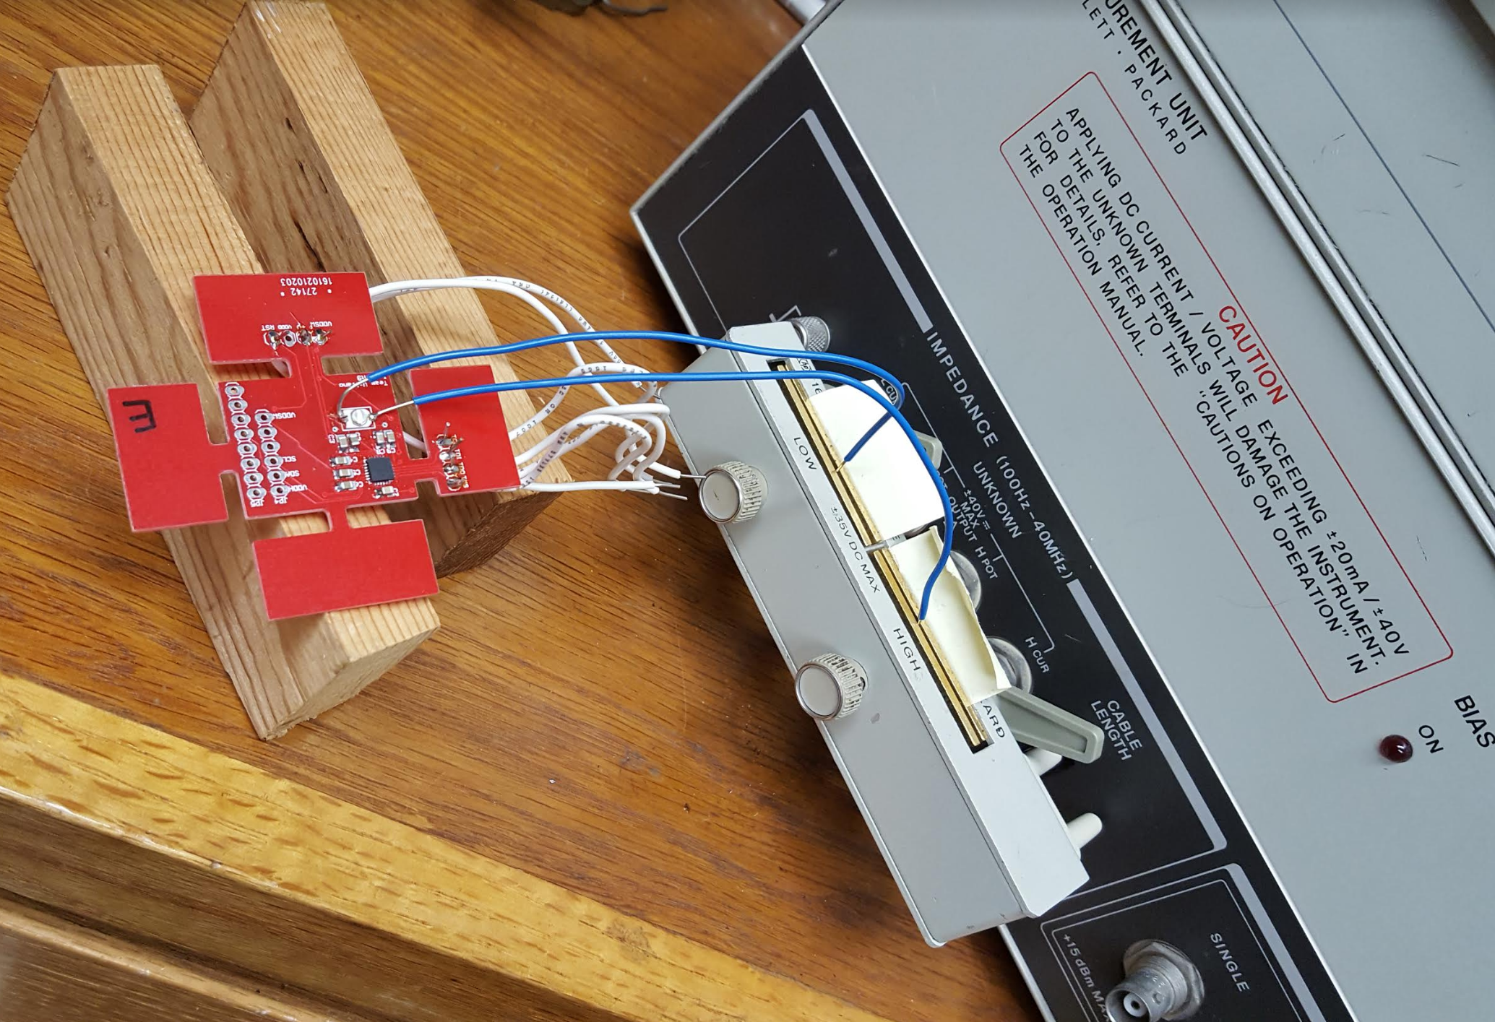

* + 1. Push “Display” to view a plot of the magnitude and phase of the impedance
    2. Use the “Knob” to view the magnitude and phase values at different frequencies
    3. Use the options to the right of the “Knob” to scale the plot differently
    4. Using the “Knob”, position the cursor on the point at which the magnitude and phase plots intersect
    5. The resonant frequency is displayed at the top of the display

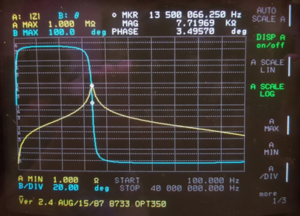

* + 1. Under “Sweep Mode”, push “Repeat” in order to continuously take measurements
    2. Using a screwdriver, adjust the tuning capacitor until you reach the desired resonant frequency of 13.56 MHz
    3. Once you reach the desired resonant frequency, push “More Menus” to access the equivalent circuit models
    4. Select the parallel RLC equivalent circuit model
    5. The equivalent R, L, and C values are displayed at the bottom of the display

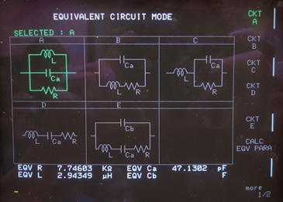

1. **The Mold**
   1. <https://appd.engr.utexas.edu/appdportal>
   2. Downloaded requisite software (Worked with Andrew on this)
      1. Logged in to virtual machine (ECE Desktop)
      2. All programs -> Solid Works 2016 (x86)
      3. File -> New -> Part
      4. Created mold
      5. Once done, saved and exported as STL file
      6. Print in Makerspace using their software
      7. See FinalDraft(1).STL for final STL file we used